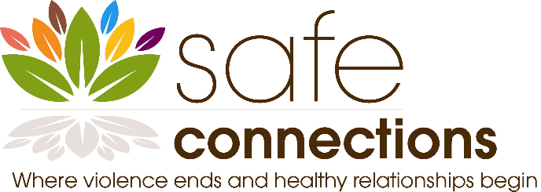

Prevention Educator – key community resource dedicated to preventing violence and promoting healthy relationships among adolescents.

  - Join Our Seasoned Organization and Make a Transformative Impact
Are you ready to reimagine what healing can look like? Do you believe every survivor deserves a voice, safety, and the chance to thrive? We are seeking exceptional Adolescent Educators who are passionate, innovative, and deeply committed to teaching and facilitating discussions with adolescents on the dynamics of domestic violence and sexual violence. If this resonates with you, we invite you to embark on this mission with us.

Who We Are
We proud to be one of the St. Louis region’s oldest and largest organization working to prevent and end domestic violence, dedicated to dismantling barriers and building safe, resilient communities. We believe in the power of survivor-centered healing and are boldly redefining prevention education, crisis intervention and therapy, making a significant difference for families and the health of our community.
Our vision: A world where every survivor is heard, believed, and equipped to reclaim joy and agency in their life.

The Role: Prevention Educator – Project HART/Girls Group
As a Prevention Educator specializing in serving students in grades 6-12, your voice will help shape the future of violence prevention by leading workshops and conversations on topics such as health relationships, teen dating violence, sexual assault awareness, setting and recognizing boundaries, self-care and empowerment.

Your Mission
- To create safer, healthier communities where all individuals are respected, valued, and free from violence.
- Through education, advocacy, and collaboration, empower youth, families, and community partners with the knowledge and skills to recognize unhealthy behaviors, challenge harmful norms, and build strong foundations of equity and respect.
- To raise awareness about domestic and sexual violence, but also to inspire meaningful action that shifts culture, promotes resilience, and prevents harm before it occurs.

Essential Responsibilities
- Facilitate Project HART presentations with youth, primarily during school-based hours.
- Distribute marketing and initiates contact with potential community partners in an effort to build programming, regularly attend community networking events to promote programming.
- Assist in the continuation of development, expansion and implementation of Project HART and other adolescent programming.
- Serve as a consultant to program partners implementing the Project HART curriculum with their youth.
- Present workshops about Project HART at local, regional and state conferences.
- Collaborate with parents/guardians and other professionals on behalf of the student.
- Act as an ambassador for our mission, both within the organization and in the greater community.

Who You Are
- Empathetic, nonjudgmental, and unflinching in your belief in survivor resilience.
- Passionate about social justice and committed to continued learning around anti-oppression and intersectionality.
- Collaborative in spirit—believing that the best outcomes emerge from shared wisdom.
- Sensitive to the diverse realities of gender, race, class, ability, sexuality, and more.
- Communicative and transparent, able to listen deeply and speak honestly.

Required Qualifications
- Bachelor’s degree in education, social services, or a related field.
- Experience in teaching or public speaking, with both adult and adolescent populations, across diverse backgrounds.
- Comfort and skill in both classroom and small group presentations.

Preferred, but Not Required
- Experience with creative, expressive, or alternative instructional formats.

Compensation, Benefits, and Culture
- Excellent benefits include 80% of medical premium paid; 100% of dental, vision, life insurance, short-term disability and long-term disability covered.
- Hybrid and flexible work schedule
- Paid vacation, sick and holidays, total of forty-three annually
- 30-hour summer work week
- Annual professional development budget—grow your passion and your expertise.
- Clinical supervision and peer consultation groups.
- Technology and travel support for hybrid work.
- Warm, values-driven workplace culture that celebrates authenticity and creativity.

How to Apply
We want to know who you are—not just what you’ve done. Please send us:
- A cover letter that captures your philosophy of healing, your connection to our mission, and a creative vision for survivor support.
- Your resume or CV.
To be considered for the position please send both to Robin Anderson, HR Generalist robin@safeconnections.org
The position will remain open until filled. No phone calls please. We welcome applicants of all backgrounds and identities. Survivors, system-impacted individuals, and those from historically marginalized communities are especially encouraged to apply.

Our Commitment
We are proud to be an equal opportunity employer. We honor and celebrate diversity in all its forms. Our workplace is inclusive, anti-racist, trauma-informed, LGBTQIA+ affirming, and accessible. If you require accommodations at any stage of the application process, please let us know.

Ready to Build Something Beautiful?
If you’re not afraid to dream—and to do—alongside us, we can’t wait to meet you. Let’s envision new possibilities for healing together.

